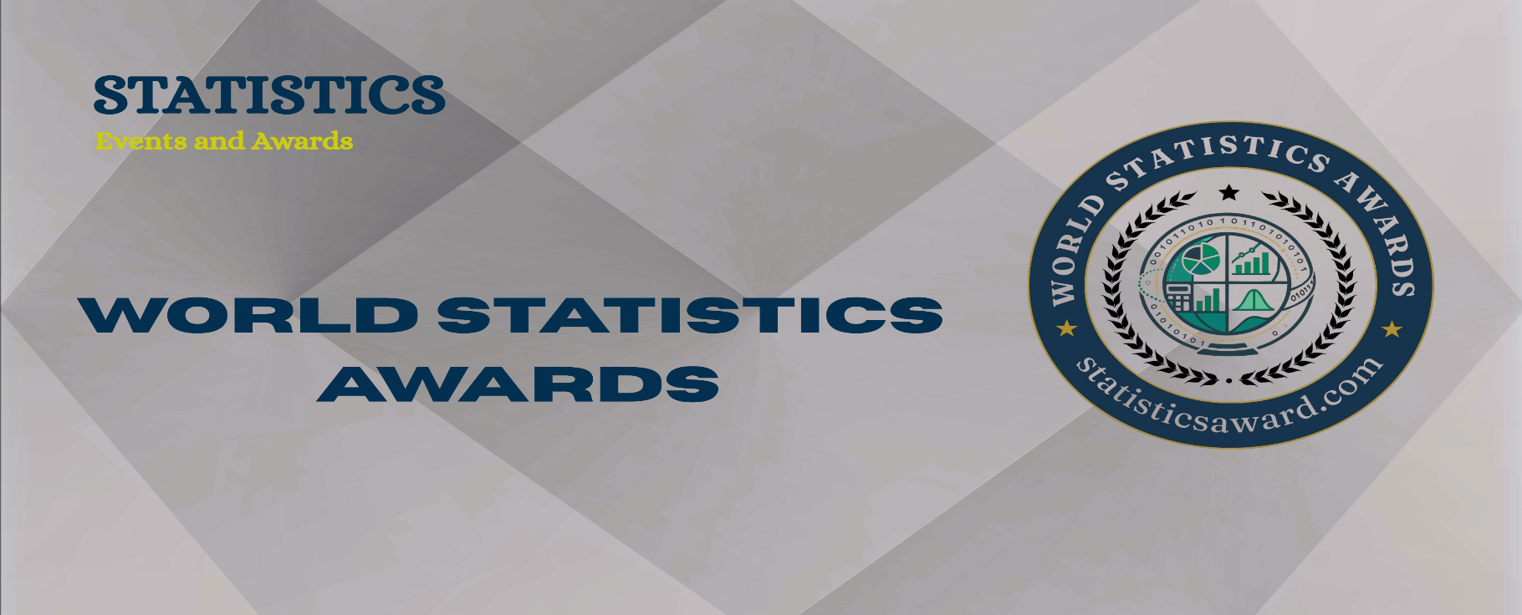

CALL FOR PROFILE – World Statistics Awards
About Awards: ScienceFather takes the privilege to awarding the Industries, Academicians, Researchers, Doctors, Scientist, and Regulators from Science, The World Statistics Awards honor exceptional contributions to statistical science and its global impact across diverse fields. Celebrating innovation, research excellence, and real-world applications, these awards recognize statisticians whose work advances knowledge, informs policy, and drives progress in healthcare, economics, technology, and beyond on an international scale.

Objectives: The International Events is awarding high quality Researchers in different subfields. The purpose of award ceremonies and assemblies is to celebrate researcher achievements and motivate them to continue on their path. The Good researchers are more motivated to succeed in their research field. People want to be respected and valued by others for their contribution. Offer the opportunity to be updated on the latest research outputs on several topics. Organize specific work shops around the most attractive and current issues. Gather worldwide experts as Event speakers.

Key Features: Excellent Venue | Inspiring Speakers | Certificate |Medal | Memento | Stage Photograph | Awardees list on website.

Award Categories: Statistical Research Excellence Award | Mathematical Statistics Award | Applied Statistics Award | Probability Theory Award | Bayesian Methods Award | Biostatistics Research Award | Time Series Award | Regression Analysis Award | Survey Sampling Award | Multivariate Analysis Award | Nonparametric Statistics Award | Statistical Computing Award | Data Visualization Award | Machine Learning Award | Big Data Analytics Award | Econometrics Research Award | Environmental Statistics Award | Health Statistics Award | Social Statistics Award | Demographic Statistics Award | Educational Statistics Award | Psychometric Methods Award | Causal Inference Award | Design of Experiments Award | Operations Research Award | Industrial Statistics Award | Actuarial Science Award | Reliability Analysis Award | Survival Analysis Award | Geospatial Statistics Award | Official Statistics Award | Financial Statistics Award | Sports Analytics Award | AI in Statistics Award | High-Dimensional Data Award | Fuzzy Statistics Award | Ethics in Statistics Award | Young Statistician Award | Women in Statistics Award | Lifetime Achievement Award

Topics of Award Subjects include, but are not limited to: Descriptive and Inferential Statistics |Probability Theory and Applications |Bayesian Statistics and Inference |Biostatistics and Epidemiology |Statistical Computing and Programming |Mathematical Statistics |Multivariate Statistical Analysis |Regression and Correlation Analysis |Time Series and Forecasting |Sampling Techniques and Survey Methods |Nonparametric Statistical Methods |Econometrics and Statistical Economics |Machine Learning and Statistics |Big Data and Statistical Analytics |Statistical Modeling and Simulation |Environmental and Climate Statistics |Statistical Quality Control (SQC) |Actuarial Science and Risk Modeling |Social and Behavioral Statistics |Demography and Population Statistics |Statistical Data Visualization |Industrial Statistics and Process Control |Bayesian Networks and Decision Theory |Geospatial and Spatial Statistics |Official and Government Statistics |Health Statistics and Public Health Analysis |Clinical Trials and Statistical Designs |Operations Research and Statistical Optimization |Educational and Psychological Measurement |Financial Statistics and Analytics |Sports Statistics and Analytics |Artificial Intelligence in Statistics |Statistical Ethics and Reproducibility |High-Dimensional Data Analysis |Survival Analysis and Reliability |Design of Experiments (DOE) |Statistical Genetics and Genomics |Causal Inference and Experimental Design |Fuzzy Statistics and Uncertainty Modelling |Statistical Applications in Engineering
For More Details statisticsaward.com For Enquiries
contact@statisticsaward.com

